CARD@ONCE USER GUIDE
CARD MUST BE BUILT IN GOLD BEFORE PRINTING A CARD
For INSTANT ISSUE CARDS ONLY
GO to the WEBSITE: https://cardatonce.eftsource.com/Home/Login
Log-on using username & password.
***Cannot remember password click Forgot your password? An email will be sent out with instructions on resetting your password. Remember you cannot use the same password.***
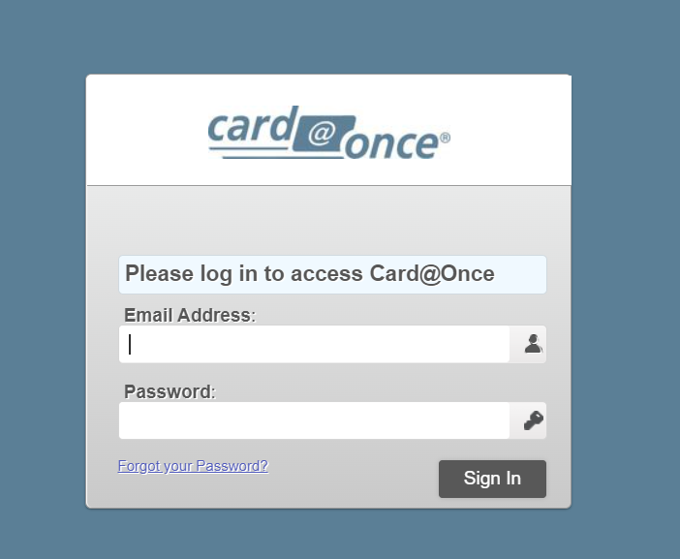
HOME DASH BOARD:
To Print a Card select the tab that say PRINT A CARD or on the top right hand corner that icon
+Print a Card 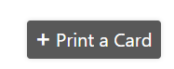
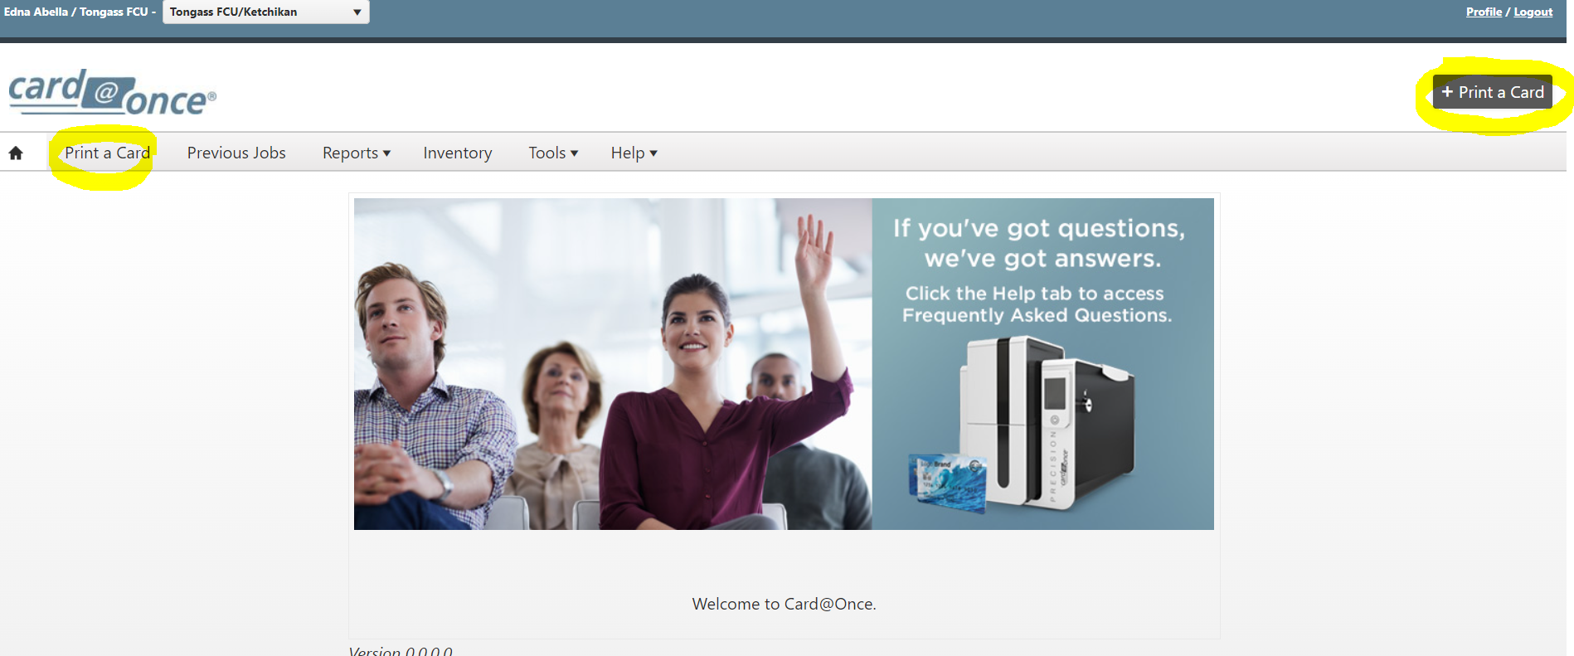

Under the Print a Card Tab: Enter Card Information
SELECT the correct type of Card you are creating.
Debit Cards:
BUSINESS DEBIT CARDS: TONGASS FCU C@O EMV BUSINESS-426164
CONSUMER DEBIT CARDS: TONGASS FCU C@O EMV CONSUMER-411393
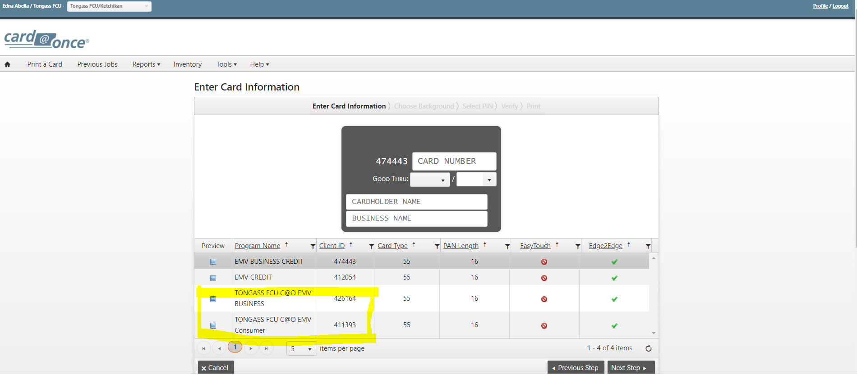
Credit Cards:
BUSINESS CREDIT CARD: EMV BUSINESS CREDIT-474443
CONSUMER CREDIT CARD: EMV CREDIT-412054
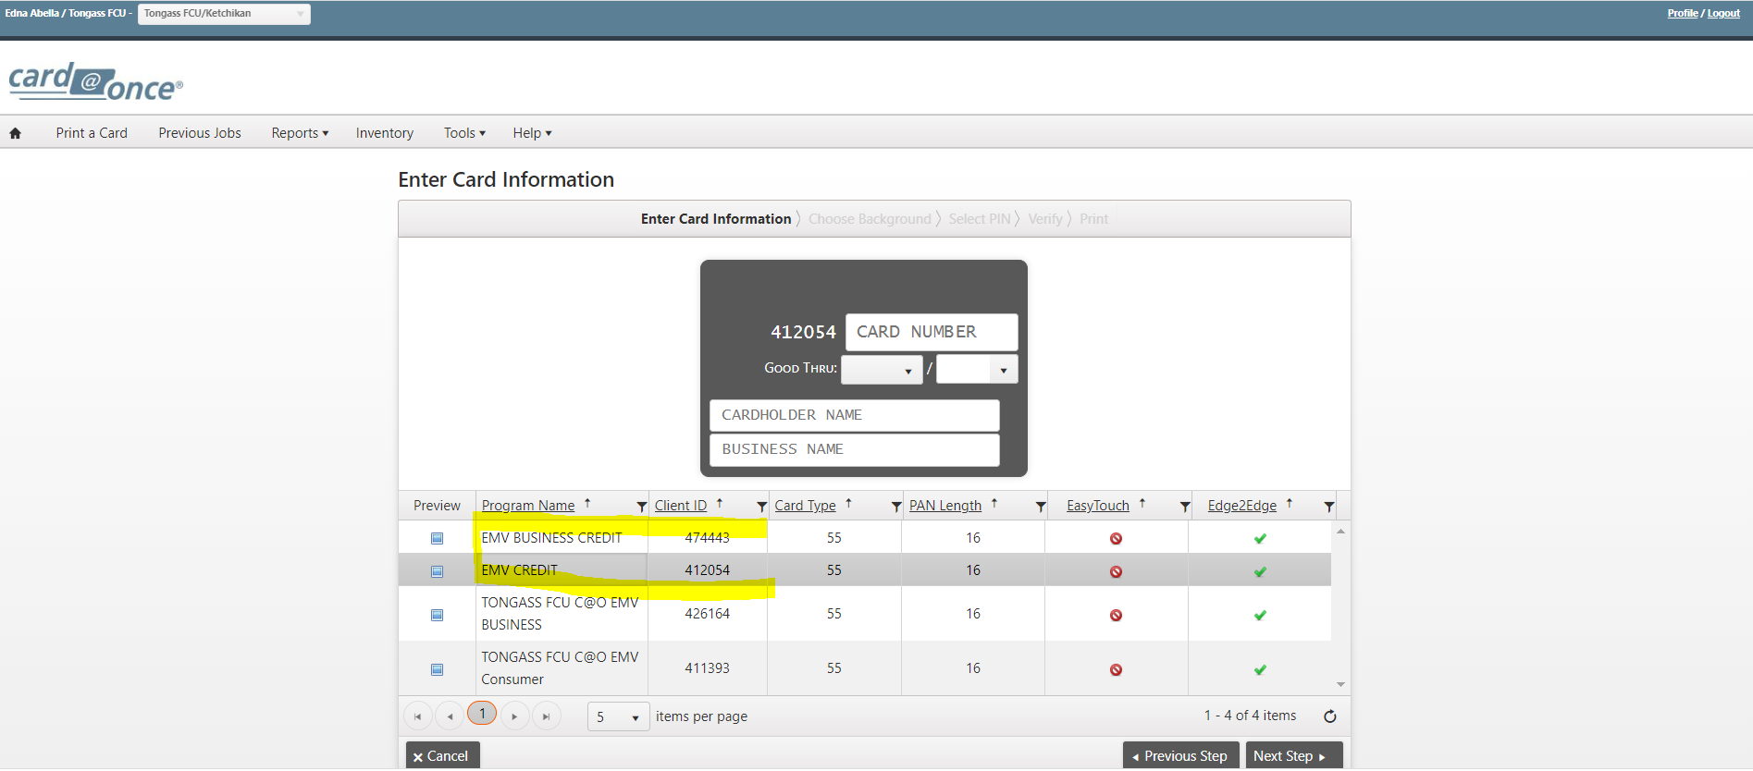

ENTER CARD INFORMATION:
REMINDER: Business Debit Card & Credit Cards-Business Name must reflect (same name) what is says in GOLD.
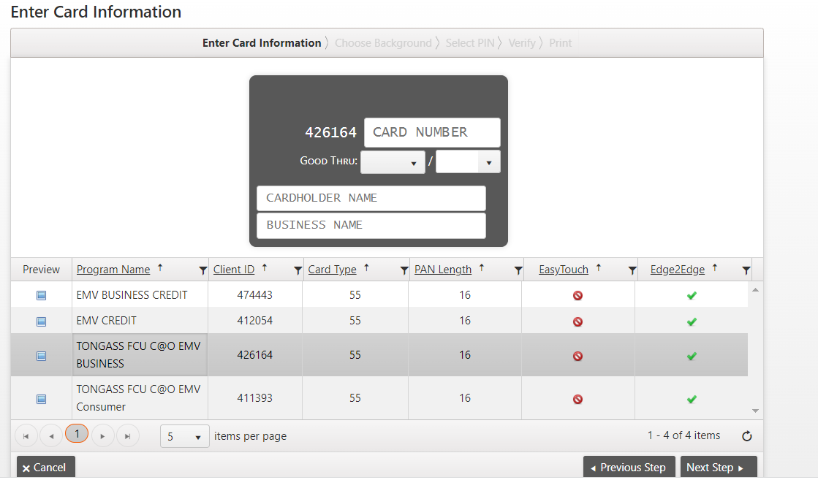
Select NEXT STEP once Card Information has been filled. 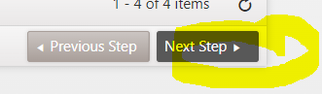
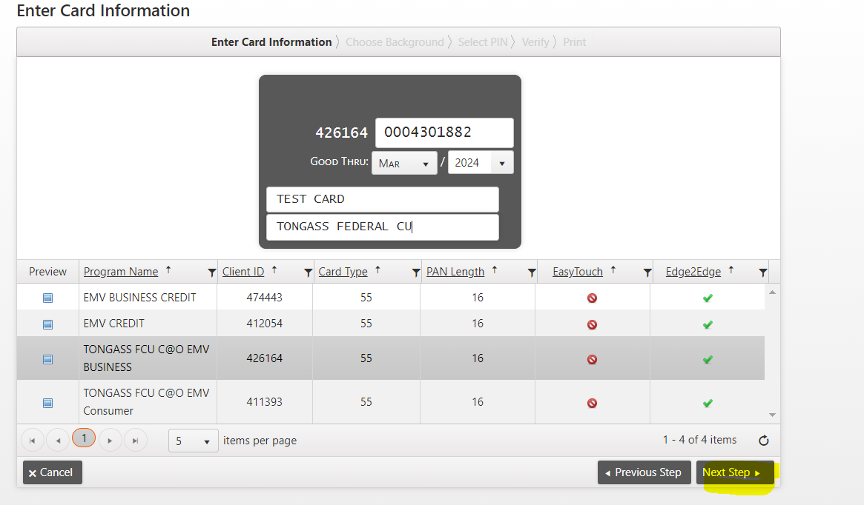
CHOOSE BACKGROUND:
Select the correct card background for the correct card you are printing. Then click NEXT STEP.
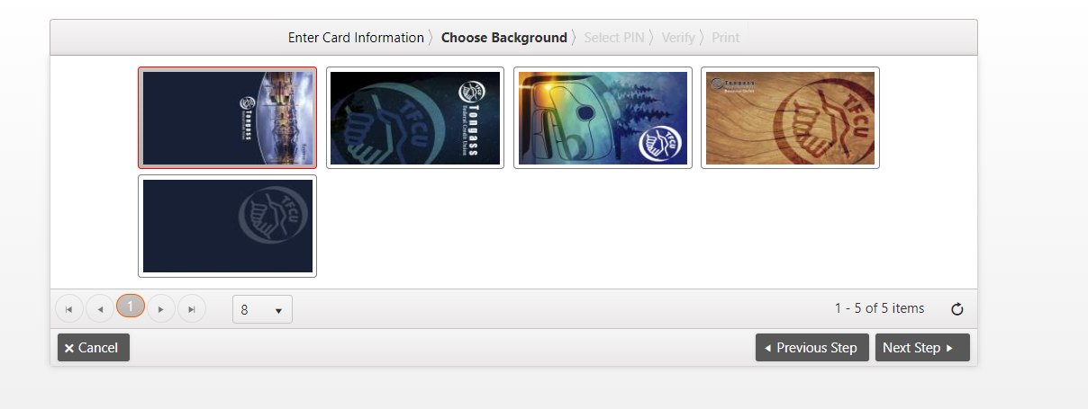
CONSUMER DEBIT CARD BACKGROUNDS

BUSINESS DEBIT CARD BACKGROUND

CONSUMER CREDIT CARD BACKGROUND

BUSINESS CREDIT CARD BACKGROUND

SELECT PIN
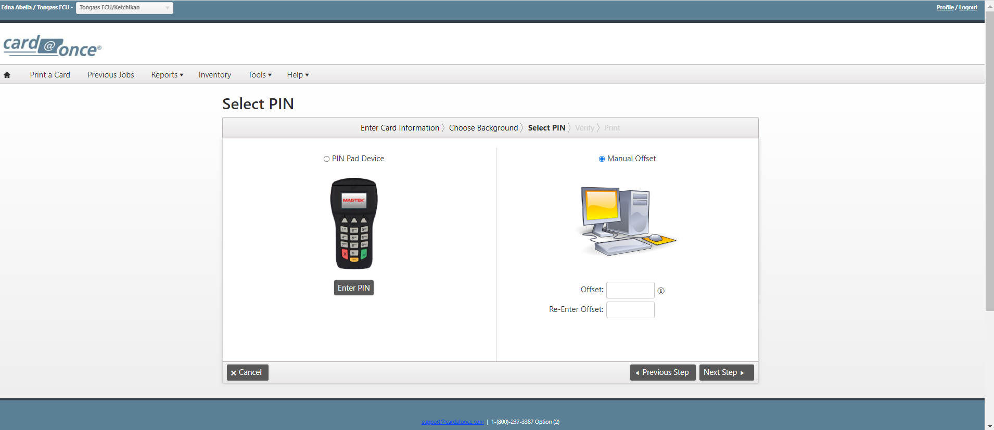
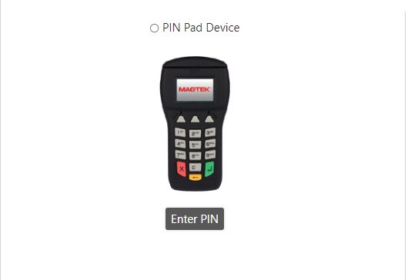
Select: PIN Pad Device

Members in branch enter their own PIN # on the PIN PAD Device. It’ll ask the member on the PIN PAD to enter 4-digit # and ask to RE-Enter it again.
Select Next Step

PIN PAD NOT WORKING? Select Manual OFFSET.
Enter: 0000
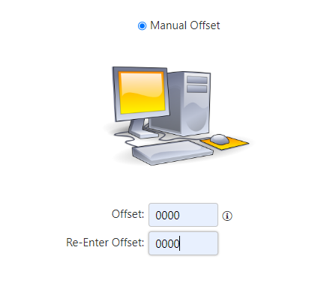
Offset: 0000
Re-Enter Offset: 0000
Select Next step.

Make sure you give the member the Re-Pin phone number to call to RE-PIN Debit Card.
Phone # 1-800-290-7893

VERIFY:
This page should be where you verify your work.
Selected correct Printer
Card holder # is correct
Expiration date matches what is in GOLD.
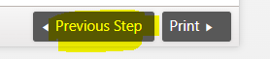
Card Holder & Business Name is spelled correctly.
*If you see any eorror select Previous Step
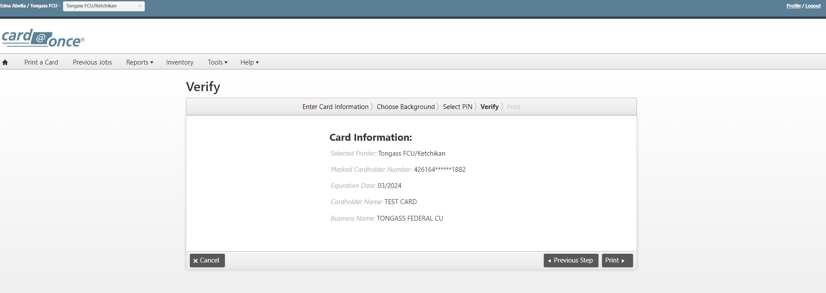
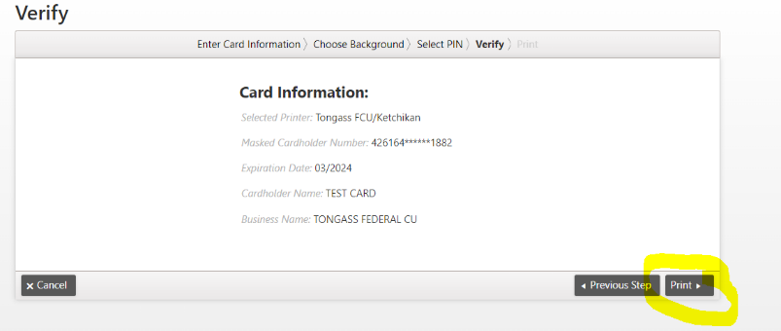
SELECT PRINT if everything is CORRECT.

PRINT:
Printing Status icon should appear.
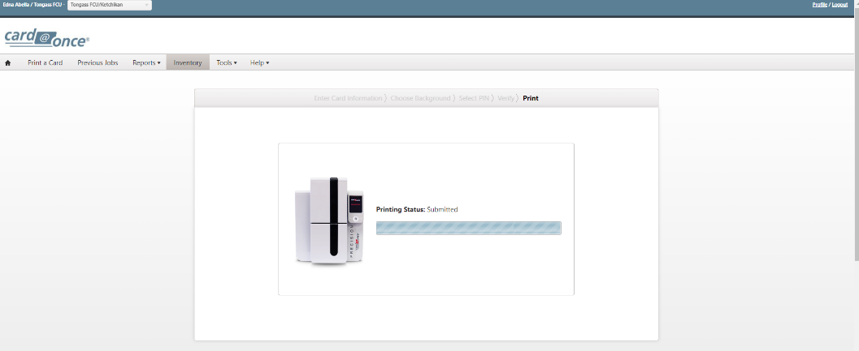
PRINTING ERROR:
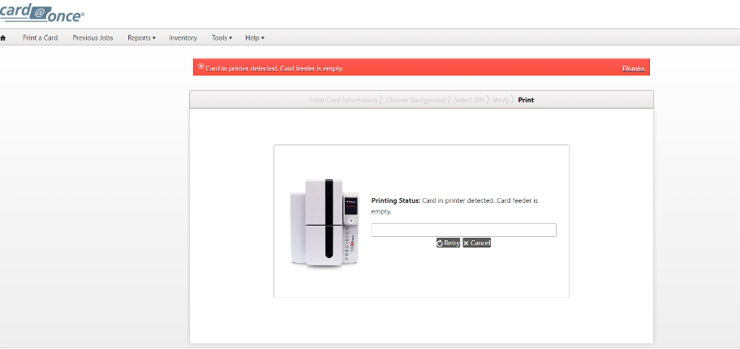
If this ERROR appears-CANCEL the Print Job.
Check the following:
- Card@Once machine is connected.
- Check for flashing lights on machine.
- Card stock (you have cards in the machine)
- Ribbon
- Internet (are you connected to the internet)
Log out of the website-Restart the process again.
If you keep getting RED ERROR MESSAGE contact CARD@ONCE
call 1-800-237-3387 Option (2)
If no ERRORS, THEN…

ACTIVIATION DEBIT CARDS (Business or Consumer):
Select Activate Card---this pop-up window will show up click OK :
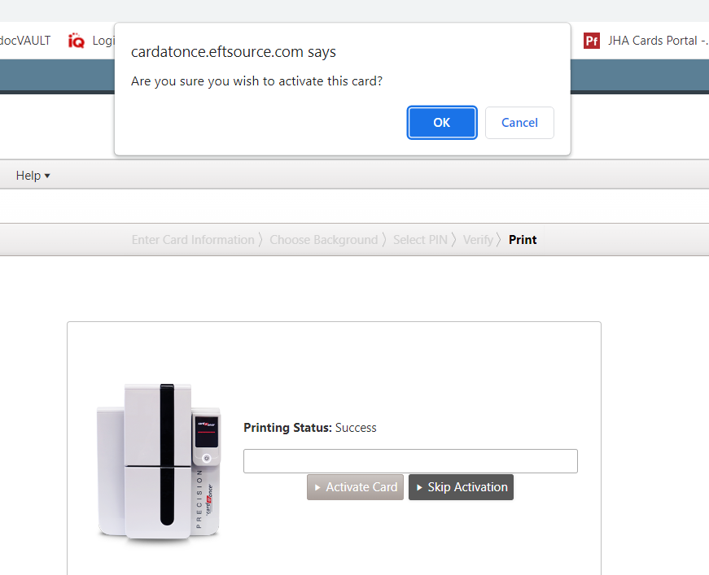

This Activiation Window will appear: fill out the following-
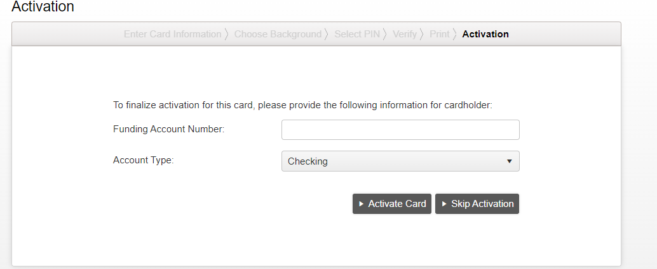
FUNDING/ACCOUNT NUMBER: Leading zeros 0000 then the member Account # (GOLD) Example: account number is 206411 you will add 4-zeros (0000). It’ll look like this-0000206411 Have a total of 10 digits for FUNDING/ACCOUNT NUMBER
******DO NOT ENTER THE MICR ACCOUNT NUMBER****
Account type: CHECKING-Debit Cards applies for both consumer and business debit cards.
******DO NOT ENTER THE MICR ACCOUNT NUMBER****

It will ask you to ACTIVIATE CARD or SKIP ACTIVATION. ALWAYS ACTIVATE THE CARD even if you are reprinting the same card number.
Please select ACTIVATE CARD.

This will then take you to this page: Under: ACTIVATED needs to say True for all Debit Cards, if it says FALSE an error has occurred. Contact VSR/Card Services for Assistance.
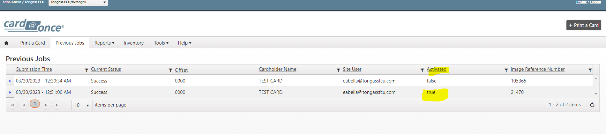

PRINT CREDIT CARDS CONSUMER & BUSINESS:
Follow the steps above like normal differences is the Print Job:
Printing Status icon should appear.----card will then Print out of the machine.
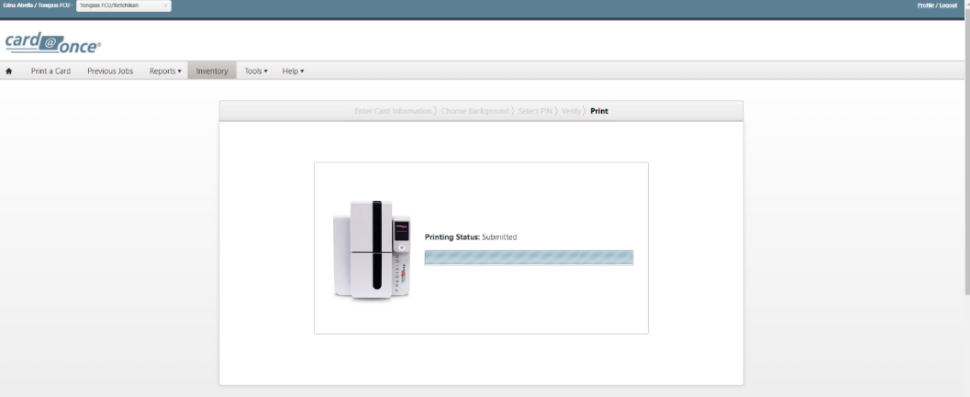

This window will then appear—CREDIT CARD-Activated will always say FALSE.
You will then GO to FIS PAYMENT ONE to activate ALL CREDIT CARDS.
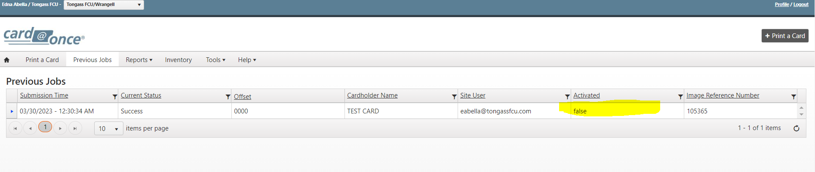

PREVIOUS JOBS Tab: Will give you a history of all the Print Job done in your Branch.
Debit Cards: We want to make sure it always say TRUE under Activated
Credit Cards: Will always say FALSE under Activated-You will need to be activiate in FIS PAYMENT ONE (Credit Card Website)
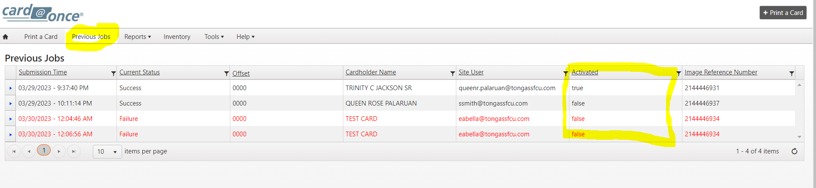
REPORTS Tab: (MANAGER ACCESS ONLY ):
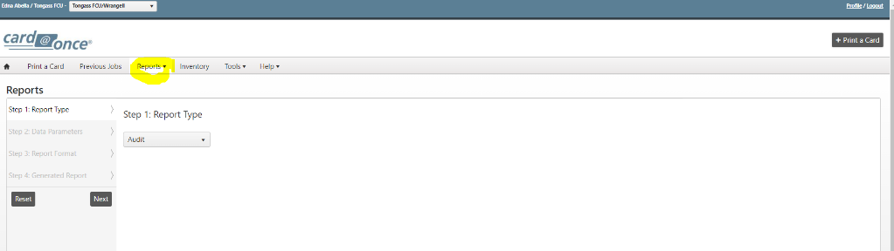
Drop-down select: Real Time Report
Step 1: Report Type-Audit

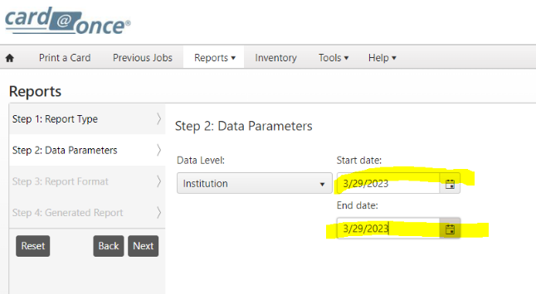
Step 2: Data Parameters
Enter Current Dates you want to look up.

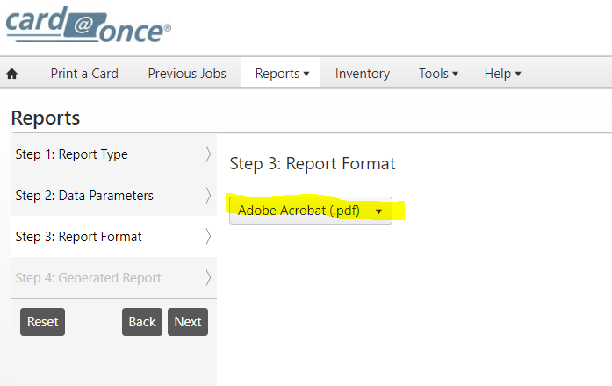
Step 3: Report Format
Leave at ADOBE ACROBAT (.pdf)

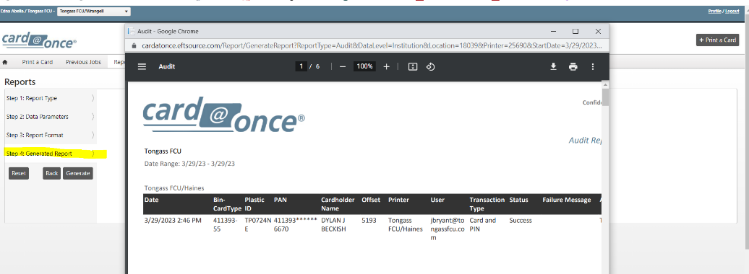
Step 4: Generated Report
This window will generate real time print reports to show any errors a print job might happen.

